**Bearing**

**No Aug**

**inception_v3**

Train: 100, Val: 96.80, Test: 95.40

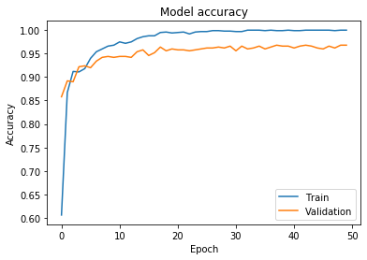 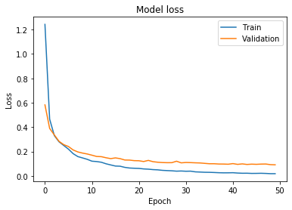

|  |  |  |  |  |  |  |  |  |  |
| --- | --- | --- | --- | --- | --- | --- | --- | --- | --- |
| 50 | 0 | 0 | 0 | 0 | 0 | 0 | 0 | 0 | 0 |
| 0 | 50 | 0 | 0 | 0 | 0 | 0 | 0 | 0 | 0 |
| 0 | 0 | 48 | 0 | 0 | 0 | 0 | 0 | 1 | 1 |
| 0 | 0 | 0 | 50 | 0 | 0 | 0 | 0 | 0 | 0 |
| 0 | 0 | 0 | 0 | 50 | 0 | 0 | 0 | 0 | 0 |
| 0 | 0 | 1 | 0 | 0 | 47 | 0 | 2 | 0 | 0 |
| 0 | 0 | 1 | 0 | 0 | 0 | 49 | 0 | 0 | 0 |
| 0 | 0 | 0 | 0 | 0 | 0 | 0 | 45 | 2 | 3 |
| 0 | 0 | 0 | 0 | 0 | 1 | 0 | 1 | 47 | 1 |
| 0 | 0 | 0 | 0 | 0 | 4 | 0 | 4 | 1 | 41 |

**Ensemble**

**inception_v3_Aug1**

Train: 100, Val: 97.4, Test: 96.40

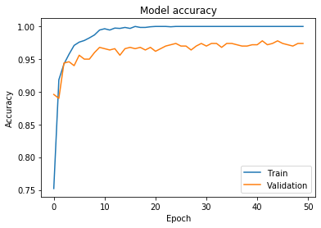 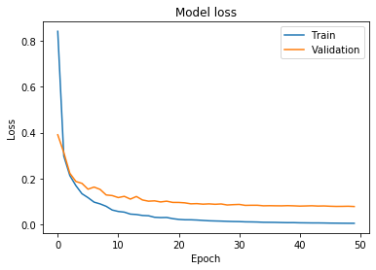

|  |  |  |  |  |  |  |  |  |  |
| --- | --- | --- | --- | --- | --- | --- | --- | --- | --- |
| 50 | 0 | 0 | 0 | 0 | 0 | 0 | 0 | 0 | 0 |
| 0 | 50 | 0 | 0 | 0 | 0 | 0 | 0 | 0 | 0 |
| 0 | 0 | 49 | 0 | 0 | 0 | 0 | 0 | 1 | 0 |
| 0 | 0 | 0 | 50 | 0 | 0 | 0 | 0 | 0 | 0 |
| 0 | 0 | 0 | 0 | 50 | 0 | 0 | 0 | 0 | 0 |
| 0 | 0 | 0 | 0 | 0 | 47 | 0 | 3 | 0 | 0 |
| 0 | 0 | 1 | 0 | 0 | 0 | 49 | 0 | 0 | 0 |
| 0 | 0 | 0 | 0 | 0 | 0 | 0 | 46 | 2 | 2 |
| 0 | 0 | 0 | 0 | 0 | 0 | 0 | 0 | 47 | 3 |
| 0 | 0 | 0 | 0 | 0 | 3 | 0 | 3 | 0 | 44 |

**inception_v3_Aug2**

Train: 100, Val: 97.2, Test: 96.40

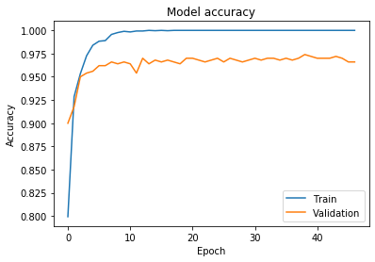 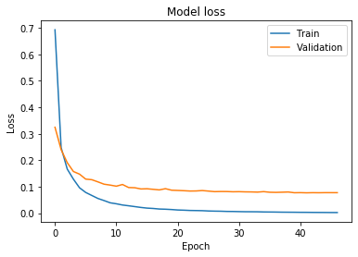

|  |  |  |  |  |  |  |  |  |  |
| --- | --- | --- | --- | --- | --- | --- | --- | --- | --- |
| 50 | 0 | 0 | 0 | 0 | 0 | 0 | 0 | 0 | 0 |
| 0 | 50 | 0 | 0 | 0 | 0 | 0 | 0 | 0 | 0 |
| 0 | 0 | 49 | 0 | 0 | 0 | 0 | 0 | 1 | 0 |
| 0 | 0 | 0 | 50 | 0 | 0 | 0 | 0 | 0 | 0 |
| 0 | 0 | 0 | 0 | 50 | 0 | 0 | 0 | 0 | 0 |
| 0 | 0 | 1 | 0 | 0 | 47 | 0 | 2 | 0 | 0 |
| 0 | 0 | 1 | 0 | 0 | 0 | 49 | 0 | 0 | 0 |
| 0 | 0 | 0 | 0 | 0 | 0 | 0 | 45 | 2 | 3 |
| 0 | 0 | 0 | 0 | 0 | 0 | 0 | 0 | 48 | 2 |
| 0 | 0 | 0 | 0 | 0 | 3 | 0 | 3 | 0 | 44 |

**inception_v3_Aug3**

Train: 100, Val: 97.4, Test: 96.4

 

|  |  |  |  |  |  |  |  |  |  |
| --- | --- | --- | --- | --- | --- | --- | --- | --- | --- |
| 50 | 0 | 0 | 0 | 0 | 0 | 0 | 0 | 0 | 0 |
| 0 | 50 | 0 | 0 | 0 | 0 | 0 | 0 | 0 | 0 |
| 0 | 0 | 49 | 0 | 0 | 0 | 0 | 0 | 1 | 0 |
| 0 | 0 | 0 | 50 | 0 | 0 | 0 | 0 | 0 | 0 |
| 0 | 0 | 0 | 0 | 50 | 0 | 0 | 0 | 0 | 0 |
| 0 | 0 | 1 | 0 | 0 | 47 | 0 | 2 | 0 | 0 |
| 0 | 0 | 1 | 0 | 0 | 0 | 49 | 0 | 0 | 0 |
| 0 | 0 | 0 | 0 | 0 | 0 | 0 | 45 | 2 | 3 |
| 0 | 0 | 0 | 0 | 0 | 0 | 0 | 0 | 48 | 2 |
| 0 | 0 | 0 | 0 | 0 | 3 | 0 | 3 | 0 | 44 |

**inception_v3_Aug4**

Train: 100, Val: 97.4, Test: 96.40

 

|  |  |  |  |  |  |  |  |  |  |
| --- | --- | --- | --- | --- | --- | --- | --- | --- | --- |
| 50 | 0 | 0 | 0 | 0 | 0 | 0 | 0 | 0 | 0 |
| 0 | 50 | 0 | 0 | 0 | 0 | 0 | 0 | 0 | 0 |
| 0 | 0 | 49 | 0 | 0 | 0 | 0 | 0 | 1 | 0 |
| 0 | 0 | 0 | 50 | 0 | 0 | 0 | 0 | 0 | 0 |
| 0 | 0 | 0 | 0 | 50 | 0 | 0 | 0 | 0 | 0 |
| 0 | 0 | 1 | 0 | 0 | 47 | 0 | 2 | 0 | 0 |
| 0 | 0 | 1 | 0 | 0 | 0 | 49 | 0 | 0 | 0 |
| 0 | 0 | 0 | 0 | 0 | 0 | 0 | 45 | 2 | 3 |
| 0 | 0 | 0 | 0 | 0 | 0 | 0 | 0 | 48 | 2 |
| 0 | 0 | 1 | 0 | 0 | 2 | 0 | 3 | 0 | 44 |

**inception_v3_Aug5**

Train: 100, Val: 97.60 Test: 96.20

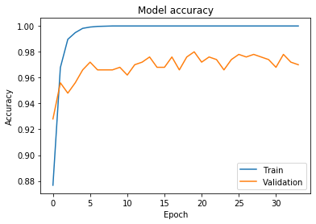 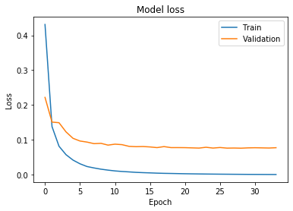

|  |  |  |  |  |  |  |  |  |  |
| --- | --- | --- | --- | --- | --- | --- | --- | --- | --- |
| 50 | 0 | 0 | 0 | 0 | 0 | 0 | 0 | 0 | 0 |
| 0 | 50 | 0 | 0 | 0 | 0 | 0 | 0 | 0 | 0 |
| 0 | 0 | 49 | 0 | 0 | 0 | 0 | 0 | 1 | 0 |
| 0 | 0 | 0 | 50 | 0 | 0 | 0 | 0 | 0 | 0 |
| 0 | 0 | 0 | 0 | 50 | 0 | 0 | 0 | 0 | 0 |
| 0 | 0 | 1 | 0 | 0 | 47 | 0 | 2 | 0 | 0 |
| 0 | 0 | 0 | 0 | 0 | 0 | 50 | 0 | 0 | 0 |
| 0 | 0 | 0 | 0 | 0 | 0 | 0 | 44 | 2 | 4 |
| 0 | 0 | 0 | 1 | 0 | 0 | 0 | 0 | 47 | 2 |
| 0 | 0 | 0 | 0 | 0 | 2 | 0 | 4 | 0 | 44 |

**inception_v3_Gan1**

Train: 99.80, Val: 96.80, Test: 94

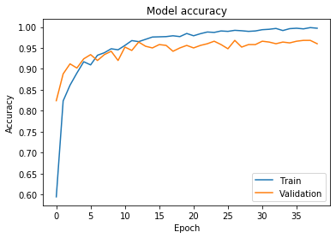 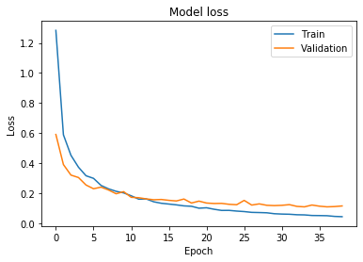

|  |  |  |  |  |  |  |  |  |  |
| --- | --- | --- | --- | --- | --- | --- | --- | --- | --- |
| 50 | 0 | 0 | 0 | 0 | 0 | 0 | 0 | 0 | 0 |
| 0 | 50 | 0 | 0 | 0 | 0 | 0 | 0 | 0 | 0 |
| 0 | 0 | 49 | 0 | 0 | 0 | 0 | 0 | 1 | 0 |
| 0 | 0 | 0 | 50 | 0 | 0 | 0 | 0 | 0 | 0 |
| 0 | 0 | 0 | 0 | 50 | 0 | 0 | 0 | 0 | 0 |
| 0 | 0 | 0 | 0 | 0 | 45 | 0 | 5 | 0 | 0 |
| 0 | 0 | 1 | 0 | 0 | 0 | 49 | 0 | 0 | 0 |
| 0 | 0 | 0 | 0 | 0 | 0 | 0 | 46 | 2 | 2 |
| 0 | 0 | 0 | 1 | 0 | 0 | 0 | 4 | 44 | 1 |
| 0 | 0 | 1 | 0 | 0 | 2 | 0 | 8 | 2 | 37 |

**inception_v3_Gan2**

Train: 99.68, Val: 95.80, Test: 95.20

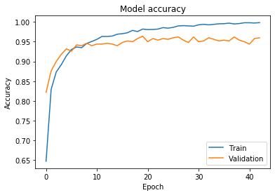 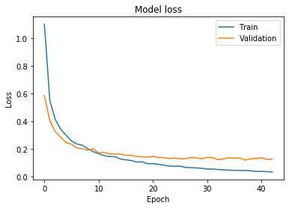

|  |  |  |  |  |  |  |  |  |  |
| --- | --- | --- | --- | --- | --- | --- | --- | --- | --- |
| 50 | 0 | 0 | 0 | 0 | 0 | 0 | 0 | 0 | 0 |
| 0 | 50 | 0 | 0 | 0 | 0 | 0 | 0 | 0 | 0 |
| 0 | 0 | 49 | 0 | 0 | 0 | 0 | 0 | 1 | 0 |
| 0 | 0 | 0 | 50 | 0 | 0 | 0 | 0 | 0 | 0 |
| 0 | 0 | 0 | 0 | 50 | 0 | 0 | 0 | 0 | 0 |
| 0 | 0 | 0 | 0 | 0 | 47 | 0 | 1 | 0 | 2 |
| 0 | 0 | 1 | 0 | 0 | 0 | 49 | 0 | 0 | 0 |
| 0 | 0 | 0 | 0 | 0 | 0 | 0 | 43 | 3 | 4 |
| 0 | 0 | 0 | 1 | 0 | 0 | 0 | 3 | 46 | 0 |
| 0 | 0 | 1 | 0 | 0 | 0 | 0 | 4 | 3 | 42 |

**inception_v3_Gan3**

Train: 99.08, Val: 96, Test: 94.4

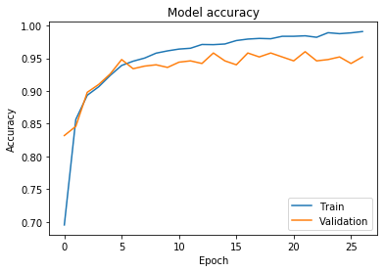 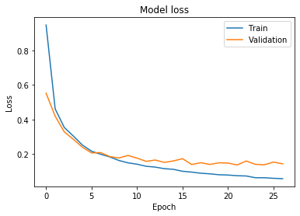

|  |  |  |  |  |  |  |  |  |  |
| --- | --- | --- | --- | --- | --- | --- | --- | --- | --- |
| 50 | 0 | 0 | 0 | 0 | 0 | 0 | 0 | 0 | 0 |
| 0 | 49 | 0 | 0 | 0 | 0 | 0 | 0 | 0 | 1 |
| 0 | 0 | 48 | 0 | 0 | 0 | 1 | 0 | 1 | 0 |
| 0 | 0 | 0 | 50 | 0 | 0 | 0 | 0 | 0 | 0 |
| 0 | 0 | 0 | 0 | 50 | 0 | 0 | 0 | 0 | 0 |
| 0 | 0 | 0 | 0 | 0 | 48 | 0 | 2 | 0 | 0 |
| 0 | 0 | 1 | 0 | 0 | 0 | 49 | 0 | 0 | 0 |
| 0 | 0 | 0 | 0 | 0 | 0 | 0 | 41 | 3 | 6 |
| 0 | 0 | 0 | 1 | 0 | 0 | 0 | 4 | 45 | 0 |
| 0 | 0 | 0 | 0 | 0 | 3 | 0 | 4 | 1 | 42 |

**inception_v3_Gan4**

Train: 98.70, Val: 95.80, Test: 94.6

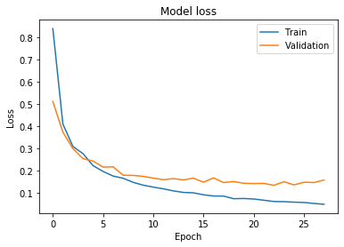 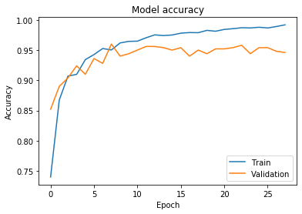

|  |  |  |  |  |  |  |  |  |  |
| --- | --- | --- | --- | --- | --- | --- | --- | --- | --- |
| 50 | 0 | 0 | 0 | 0 | 0 | 0 | 0 | 0 | 0 |
| 0 | 49 | 0 | 0 | 0 | 0 | 0 | 0 | 0 | 1 |
| 0 | 0 | 48 | 0 | 0 | 0 | 1 | 0 | 1 | 0 |
| 0 | 0 | 0 | 50 | 0 | 0 | 0 | 0 | 0 | 0 |
| 0 | 0 | 0 | 0 | 50 | 0 | 0 | 0 | 0 | 0 |
| 0 | 0 | 0 | 0 | 0 | 47 | 0 | 2 | 0 | 1 |
| 0 | 0 | 1 | 0 | 0 | 0 | 49 | 0 | 0 | 0 |
| 0 | 0 | 0 | 0 | 0 | 0 | 0 | 41 | 2 | 7 |
| 0 | 0 | 0 | 1 | 0 | 1 | 0 | 3 | 45 | 0 |
| 0 | 0 | 0 | 0 | 0 | 0 | 0 | 5 | 1 | 44 |

**inception_v3_Gan5**

Train: 98.9, Val: 95.0, Test: 94.6

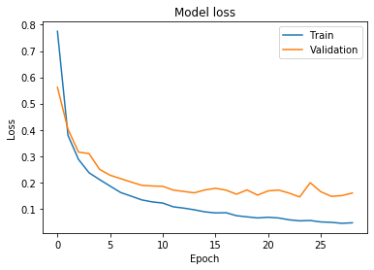 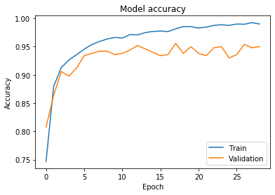

|  |  |  |  |  |  |  |  |  |  |
| --- | --- | --- | --- | --- | --- | --- | --- | --- | --- |
| 50 | 0 | 0 | 0 | 0 | 0 | 0 | 0 | 0 | 0 |
| 0 | 49 | 0 | 0 | 0 | 0 | 0 | 0 | 0 | 1 |
| 0 | 0 | 49 | 0 | 0 | 0 | 0 | 0 | 1 | 0 |
| 0 | 0 | 0 | 50 | 0 | 0 | 0 | 0 | 0 | 0 |
| 0 | 0 | 0 | 0 | 50 | 0 | 0 | 0 | 0 | 0 |
| 0 | 0 | 0 | 0 | 0 | 46 | 0 | 3 | 0 | 1 |
| 0 | 0 | 1 | 0 | 0 | 0 | 49 | 0 | 0 | 0 |
| 0 | 0 | 0 | 0 | 0 | 0 | 0 | 41 | 2 | 7 |
| 0 | 0 | 0 | 1 | 0 | 1 | 0 | 3 | 44 | 1 |
| 0 | 0 | 0 | 0 | 0 | 0 | 0 | 4 | 1 | 45 |

**mobilenet_v2**

**No Aug**

Train: 100, Val: 98.40, Test: 98

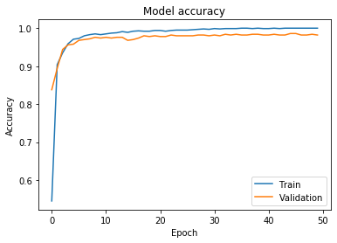 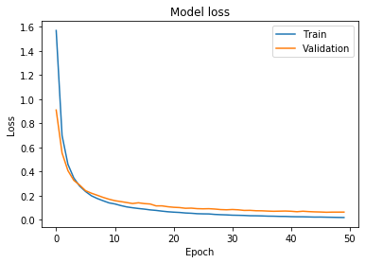

|  |  |  |  |  |  |  |  |  |  |
| --- | --- | --- | --- | --- | --- | --- | --- | --- | --- |
| 50 | 0 | 0 | 0 | 0 | 0 | 0 | 0 | 0 | 0 |
| 0 | 50 | 0 | 0 | 0 | 0 | 0 | 0 | 0 | 0 |
| 0 | 0 | 50 | 0 | 0 | 0 | 0 | 0 | 0 | 0 |
| 0 | 0 | 0 | 50 | 0 | 0 | 0 | 0 | 0 | 0 |
| 0 | 0 | 0 | 0 | 50 | 0 | 0 | 0 | 0 | 0 |
| 0 | 0 | 0 | 0 | 0 | 49 | 0 | 0 | 0 | 1 |
| 0 | 0 | 0 | 0 | 0 | 0 | 50 | 0 | 0 | 0 |
| 0 | 0 | 0 | 0 | 0 | 0 | 0 | 50 | 0 | 0 |
| 0 | 0 | 0 | 0 | 0 | 0 | 0 | 4 | 46 | 0 |
| 0 | 0 | 0 | 0 | 0 | 0 | 0 | 4 | 1 | 45 |

**mobilenet_v2_Aug1**

Train: 100, Val: 98.40, Test: 98.8

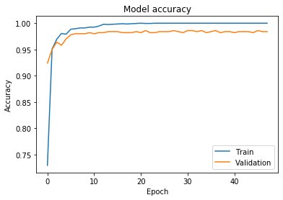 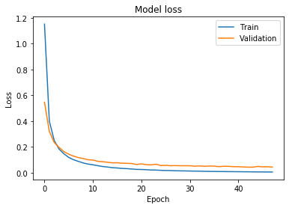

|  |  |  |  |  |  |  |  |  |  |
| --- | --- | --- | --- | --- | --- | --- | --- | --- | --- |
| 50 | 0 | 0 | 0 | 0 | 0 | 0 | 0 | 0 | 0 |
| 0 | 50 | 0 | 0 | 0 | 0 | 0 | 0 | 0 | 0 |
| 0 | 0 | 50 | 0 | 0 | 0 | 0 | 0 | 0 | 0 |
| 0 | 0 | 0 | 50 | 0 | 0 | 0 | 0 | 0 | 0 |
| 0 | 0 | 0 | 0 | 50 | 0 | 0 | 0 | 0 | 0 |
| 0 | 0 | 0 | 0 | 0 | 49 | 0 | 0 | 0 | 1 |
| 0 | 0 | 0 | 0 | 0 | 0 | 50 | 0 | 0 | 0 |
| 0 | 0 | 0 | 0 | 0 | 0 | 0 | 50 | 0 | 0 |
| 0 | 0 | 0 | 0 | 0 | 0 | 0 | 2 | 48 | 0 |
| 0 | 0 | 0 | 0 | 0 | 0 | 0 | 2 | 1 | 47 |

**mobilenet_v2 Aug2**

Train: 100, Val: 98.60, Test: 98.6

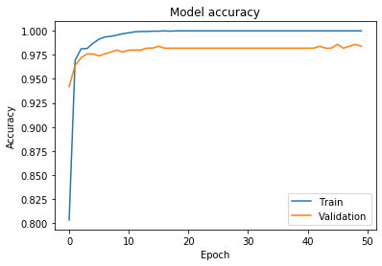 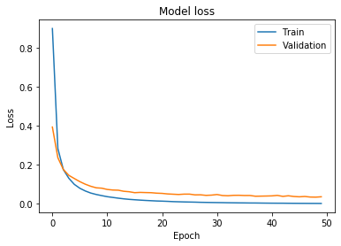

|  |  |  |  |  |  |  |  |  |  |
| --- | --- | --- | --- | --- | --- | --- | --- | --- | --- |
| 50 | 0 | 0 | 0 | 0 | 0 | 0 | 0 | 0 | 0 |
| 0 | 50 | 0 | 0 | 0 | 0 | 0 | 0 | 0 | 0 |
| 0 | 0 | 50 | 0 | 0 | 0 | 0 | 0 | 0 | 0 |
| 0 | 0 | 0 | 50 | 0 | 0 | 0 | 0 | 0 | 0 |
| 0 | 0 | 0 | 0 | 50 | 0 | 0 | 0 | 0 | 0 |
| 0 | 0 | 0 | 0 | 0 | 49 | 0 | 0 | 0 | 1 |
| 0 | 0 | 0 | 0 | 0 | 0 | 50 | 0 | 0 | 0 |
| 0 | 0 | 0 | 0 | 0 | 0 | 0 | 50 | 0 | 0 |
| 0 | 0 | 0 | 0 | 0 | 0 | 0 | 2 | 48 | 0 |
| 0 | 0 | 0 | 0 | 0 | 0 | 0 | 3 | 1 | 46 |

**mobilenet_v2 Aug3**

Train: 100, Val: 98.60, Test: 98.6

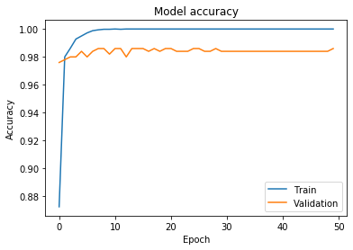 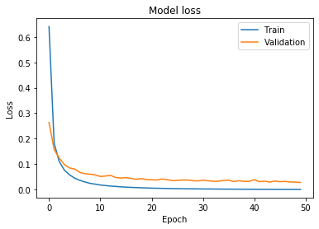

|  |  |  |  |  |  |  |  |  |  |
| --- | --- | --- | --- | --- | --- | --- | --- | --- | --- |
| 50 | 0 | 0 | 0 | 0 | 0 | 0 | 0 | 0 | 0 |
| 0 | 50 | 0 | 0 | 0 | 0 | 0 | 0 | 0 | 0 |
| 0 | 0 | 50 | 0 | 0 | 0 | 0 | 0 | 0 | 0 |
| 0 | 0 | 0 | 50 | 0 | 0 | 0 | 0 | 0 | 0 |
| 0 | 0 | 0 | 0 | 50 | 0 | 0 | 0 | 0 | 0 |
| 0 | 0 | 0 | 0 | 0 | 49 | 0 | 0 | 0 | 1 |
| 0 | 0 | 0 | 0 | 0 | 0 | 50 | 0 | 0 | 0 |
| 0 | 0 | 0 | 0 | 0 | 0 | 0 | 50 | 0 | 0 |
| 0 | 0 | 0 | 0 | 0 | 0 | 0 | 2 | 48 | 0 |
| 0 | 0 | 0 | 0 | 0 | 0 | 0 | 3 | 1 | 46 |

**mobilenet_v2 Aug4**

Train: 100, Val: 98.60, Test: 98.6

 

|  |  |  |  |  |  |  |  |  |  |
| --- | --- | --- | --- | --- | --- | --- | --- | --- | --- |
| 50 | 0 | 0 | 0 | 0 | 0 | 0 | 0 | 0 | 0 |
| 0 | 50 | 0 | 0 | 0 | 0 | 0 | 0 | 0 | 0 |
| 0 | 0 | 50 | 0 | 0 | 0 | 0 | 0 | 0 | 0 |
| 0 | 0 | 0 | 50 | 0 | 0 | 0 | 0 | 0 | 0 |
| 0 | 0 | 0 | 0 | 50 | 0 | 0 | 0 | 0 | 0 |
| 0 | 0 | 0 | 0 | 0 | 49 | 0 | 0 | 0 | 1 |
| 0 | 0 | 0 | 0 | 0 | 0 | 50 | 0 | 0 | 0 |
| 0 | 0 | 0 | 0 | 0 | 0 | 0 | 50 | 0 | 0 |
| 0 | 0 | 0 | 0 | 0 | 0 | 0 | 2 | 48 | 0 |
| 0 | 0 | 0 | 0 | 0 | 0 | 0 | 3 | 1 | 46 |

**mobilenet_v2 Aug5**

Train: 100, Val: 98.60, Test: 98.6

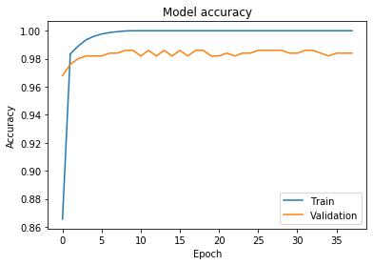 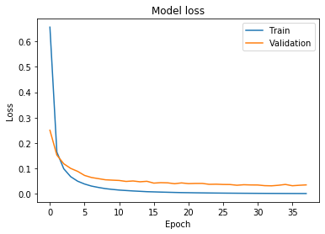

|  |  |  |  |  |  |  |  |  |  |
| --- | --- | --- | --- | --- | --- | --- | --- | --- | --- |
| 50 | 0 | 0 | 0 | 0 | 0 | 0 | 0 | 0 | 0 |
| 0 | 50 | 0 | 0 | 0 | 0 | 0 | 0 | 0 | 0 |
| 0 | 0 | 50 | 0 | 0 | 0 | 0 | 0 | 0 | 0 |
| 0 | 0 | 0 | 50 | 0 | 0 | 0 | 0 | 0 | 0 |
| 0 | 0 | 0 | 0 | 50 | 0 | 0 | 0 | 0 | 0 |
| 0 | 0 | 0 | 0 | 0 | 49 | 0 | 0 | 0 | 1 |
| 0 | 0 | 0 | 0 | 0 | 0 | 50 | 0 | 0 | 0 |
| 0 | 0 | 0 | 0 | 0 | 0 | 0 | 50 | 0 | 0 |
| 0 | 0 | 0 | 0 | 0 | 0 | 0 | 2 | 48 | 0 |
| 0 | 0 | 0 | 0 | 0 | 0 | 0 | 3 | 1 | 46 |

**mobilenet_v2 Gan1**

Train: 99.86, Val: 98.60, Test: 98.4

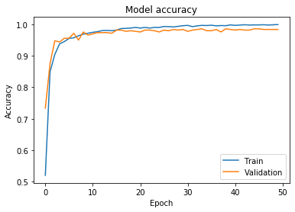 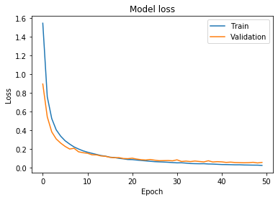

|  |  |  |  |  |  |  |  |  |  |
| --- | --- | --- | --- | --- | --- | --- | --- | --- | --- |
| 50 | 0 | 0 | 0 | 0 | 0 | 0 | 0 | 0 | 0 |
| 0 | 50 | 0 | 0 | 0 | 0 | 0 | 0 | 0 | 0 |
| 0 | 0 | 50 | 0 | 0 | 0 | 0 | 0 | 0 | 0 |
| 0 | 0 | 0 | 50 | 0 | 0 | 0 | 0 | 0 | 0 |
| 0 | 0 | 0 | 0 | 50 | 0 | 0 | 0 | 0 | 0 |
| 0 | 0 | 0 | 0 | 0 | 49 | 0 | 0 | 0 | 1 |
| 0 | 0 | 0 | 0 | 0 | 0 | 50 | 0 | 0 | 0 |
| 0 | 0 | 0 | 0 | 0 | 0 | 0 | 49 | 0 | 1 |
| 0 | 0 | 0 | 0 | 0 | 0 | 0 | 3 | 47 | 0 |
| 0 | 0 | 0 | 0 | 0 | 0 | 0 | 2 | 1 | 47 |

**mobilenet_v2 Gan2**

Train: 99.83, Val: 98.40, Test: 98.2

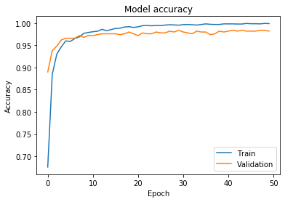 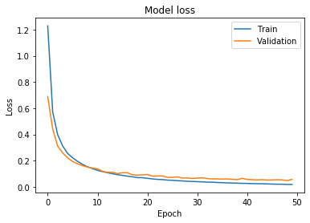

|  |  |  |  |  |  |  |  |  |  |
| --- | --- | --- | --- | --- | --- | --- | --- | --- | --- |
| 50 | 0 | 0 | 0 | 0 | 0 | 0 | 0 | 0 | 0 |
| 0 | 50 | 0 | 0 | 0 | 0 | 0 | 0 | 0 | 0 |
| 0 | 0 | 50 | 0 | 0 | 0 | 0 | 0 | 0 | 0 |
| 0 | 0 | 0 | 50 | 0 | 0 | 0 | 0 | 0 | 0 |
| 0 | 0 | 0 | 0 | 50 | 0 | 0 | 0 | 0 | 0 |
| 0 | 0 | 0 | 0 | 0 | 49 | 0 | 0 | 0 | 1 |
| 0 | 0 | 0 | 0 | 0 | 0 | 50 | 0 | 0 | 0 |
| 0 | 0 | 0 | 0 | 0 | 0 | 0 | 49 | 0 | 1 |
| 0 | 0 | 0 | 0 | 0 | 0 | 0 | 3 | 47 | 0 |
| 0 | 0 | 0 | 0 | 0 | 0 | 0 | 3 | 1 | 46 |

**mobilenet_v2 Gan3**

Train: 99.87, Val: 98.40, Test: 98

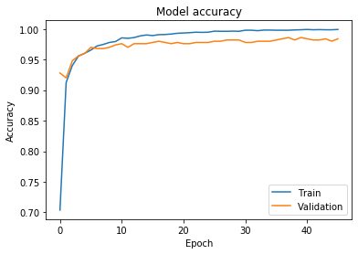 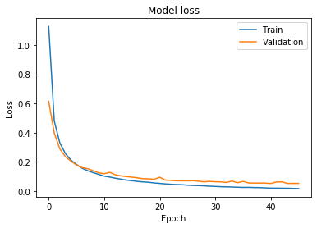

|  |  |  |  |  |  |  |  |  |  |
| --- | --- | --- | --- | --- | --- | --- | --- | --- | --- |
| 50 | 0 | 0 | 0 | 0 | 0 | 0 | 0 | 0 | 0 |
| 0 | 50 | 0 | 0 | 0 | 0 | 0 | 0 | 0 | 0 |
| 0 | 0 | 50 | 0 | 0 | 0 | 0 | 0 | 0 | 0 |
| 0 | 0 | 0 | 50 | 0 | 0 | 0 | 0 | 0 | 0 |
| 0 | 0 | 0 | 0 | 50 | 0 | 0 | 0 | 0 | 0 |
| 0 | 0 | 0 | 0 | 0 | 49 | 0 | 0 | 0 | 1 |
| 0 | 0 | 0 | 0 | 0 | 0 | 50 | 0 | 0 | 0 |
| 0 | 0 | 0 | 0 | 0 | 0 | 0 | 49 | 0 | 1 |
| 0 | 0 | 0 | 0 | 0 | 0 | 0 | 3 | 46 | 1 |
| 0 | 0 | 0 | 0 | 0 | 0 | 0 | 3 | 1 | 46 |

**mobilenet_v2 Gan4**

Train: 99.76, Val: 98.60, Test: 97.8

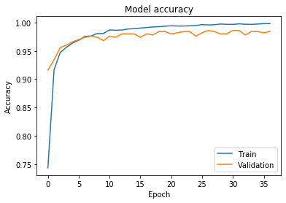 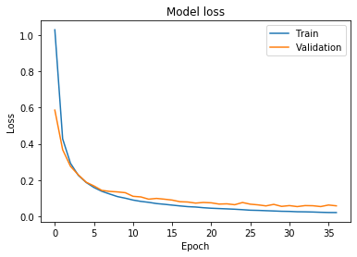

|  |  |  |  |  |  |  |  |  |  |
| --- | --- | --- | --- | --- | --- | --- | --- | --- | --- |
| 50 | 0 | 0 | 0 | 0 | 0 | 0 | 0 | 0 | 0 |
| 0 | 50 | 0 | 0 | 0 | 0 | 0 | 0 | 0 | 0 |
| 0 | 0 | 50 | 0 | 0 | 0 | 0 | 0 | 0 | 0 |
| 0 | 0 | 0 | 50 | 0 | 0 | 0 | 0 | 0 | 0 |
| 0 | 0 | 0 | 0 | 50 | 0 | 0 | 0 | 0 | 0 |
| 0 | 0 | 0 | 0 | 0 | 49 | 0 | 0 | 0 | 1 |
| 0 | 0 | 0 | 0 | 0 | 0 | 50 | 0 | 0 | 0 |
| 0 | 0 | 0 | 0 | 0 | 0 | 0 | 49 | 0 | 1 |
| 0 | 0 | 0 | 0 | 0 | 0 | 0 | 3 | 46 | 1 |
| 0 | 0 | 0 | 0 | 0 | 0 | 0 | 3 | 1 | 46 |

**mobilenet_v2 Gan5**

Train: 99.92, Val: 98.40, Test: 98.4

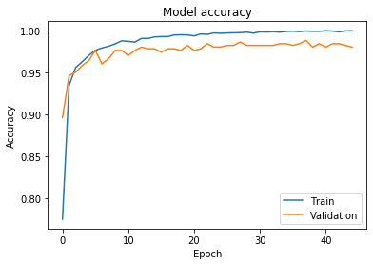 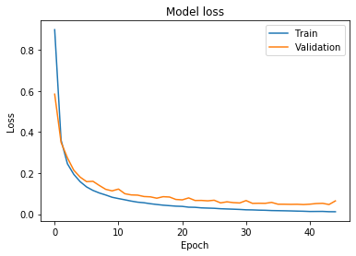

|  |  |  |  |  |  |  |  |  |  |
| --- | --- | --- | --- | --- | --- | --- | --- | --- | --- |
| 50 | 0 | 0 | 0 | 0 | 0 | 0 | 0 | 0 | 0 |
| 0 | 50 | 0 | 0 | 0 | 0 | 0 | 0 | 0 | 0 |
| 0 | 0 | 50 | 0 | 0 | 0 | 0 | 0 | 0 | 0 |
| 0 | 0 | 0 | 50 | 0 | 0 | 0 | 0 | 0 | 0 |
| 0 | 0 | 0 | 0 | 50 | 0 | 0 | 0 | 0 | 0 |
| 0 | 0 | 0 | 0 | 0 | 49 | 0 | 0 | 0 | 1 |
| 0 | 0 | 0 | 0 | 0 | 0 | 50 | 0 | 0 | 0 |
| 0 | 0 | 0 | 0 | 0 | 0 | 0 | 49 | 0 | 1 |
| 0 | 0 | 0 | 0 | 0 | 0 | 0 | 2 | 48 | 0 |
| 0 | 0 | 0 | 0 | 0 | 0 | 0 | 3 | 1 | 46 |

**ResNet 50**

Train: 100, Val: 99, Test: 98.4

|  |  |  |  |  |  |  |  |  |  |
| --- | --- | --- | --- | --- | --- | --- | --- | --- | --- |
| 50 | 0 | 0 | 0 | 0 | 0 | 0 | 0 | 0 | 0 |
| 0 | 50 | 0 | 0 | 0 | 0 | 0 | 0 | 0 | 0 |
| 0 | 0 | 50 | 0 | 0 | 0 | 0 | 0 | 0 | 0 |
| 0 | 0 | 0 | 50 | 0 | 0 | 0 | 0 | 0 | 0 |
| 0 | 0 | 0 | 0 | 50 | 0 | 0 | 0 | 0 | 0 |
| 0 | 0 | 0 | 0 | 0 | 50 | 0 | 0 | 0 | 0 |
| 0 | 0 | 1 | 0 | 0 | 0 | 49 | 0 | 0 | 0 |
| 0 | 0 | 0 | 0 | 0 | 0 | 0 | 48 | 1 | 1 |
| 0 | 0 | 0 | 1 | 0 | 0 | 0 | 2 | 47 | 0 |
| 0 | 0 | 0 | 0 | 0 | 0 | 0 | 2 | 0 | 48 |

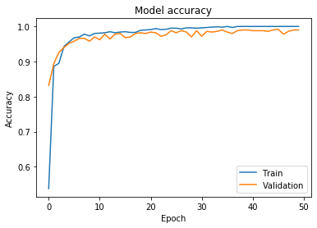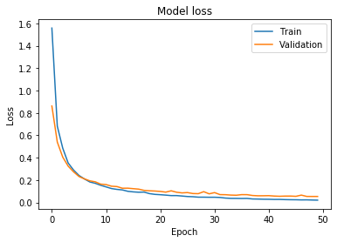

**ResNet 50_Aug1**

Train: 100, Val: 99, Test: 98.4

|  |  |  |  |  |  |  |  |  |  |
| --- | --- | --- | --- | --- | --- | --- | --- | --- | --- |
| 50 | 0 | 0 | 0 | 0 | 0 | 0 | 0 | 0 | 0 |
| 0 | 50 | 0 | 0 | 0 | 0 | 0 | 0 | 0 | 0 |
| 0 | 0 | 50 | 0 | 0 | 0 | 0 | 0 | 0 | 0 |
| 0 | 0 | 0 | 50 | 0 | 0 | 0 | 0 | 0 | 0 |
| 0 | 0 | 0 | 0 | 50 | 0 | 0 | 0 | 0 | 0 |
| 0 | 0 | 0 | 0 | 0 | 50 | 0 | 0 | 0 | 0 |
| 0 | 0 | 1 | 0 | 0 | 0 | 49 | 0 | 0 | 0 |
| 0 | 0 | 0 | 0 | 0 | 0 | 0 | 47 | 1 | 2 |
| 0 | 0 | 0 | 0 | 0 | 0 | 0 | 2 | 48 | 0 |
| 0 | 0 | 0 | 0 | 0 | 0 | 0 | 2 | 0 | 48 |

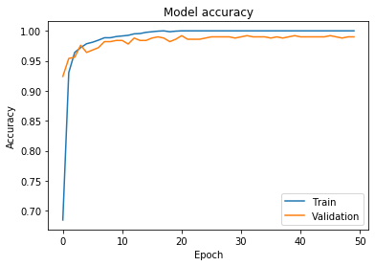 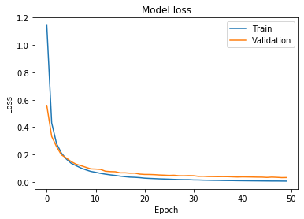

**ResNet 50_Aug2**

Train: 100, Val: 99.4, Test: 98.6

|  |  |  |  |  |  |  |  |  |  |
| --- | --- | --- | --- | --- | --- | --- | --- | --- | --- |
| 50 | 0 | 0 | 0 | 0 | 0 | 0 | 0 | 0 | 0 |
| 0 | 50 | 0 | 0 | 0 | 0 | 0 | 0 | 0 | 0 |
| 0 | 0 | 50 | 0 | 0 | 0 | 0 | 0 | 0 | 0 |
| 0 | 0 | 0 | 50 | 0 | 0 | 0 | 0 | 0 | 0 |
| 0 | 0 | 0 | 0 | 50 | 0 | 0 | 0 | 0 | 0 |
| 0 | 0 | 0 | 0 | 0 | 50 | 0 | 0 | 0 | 0 |
| 0 | 0 | 1 | 0 | 0 | 0 | 49 | 0 | 0 | 0 |
| 0 | 0 | 0 | 0 | 0 | 0 | 0 | 47 | 1 | 2 |
| 0 | 0 | 0 | 0 | 0 | 0 | 0 | 2 | 48 | 0 |
| 0 | 0 | 0 | 0 | 0 | 0 | 0 | 1 | 0 | 49 |

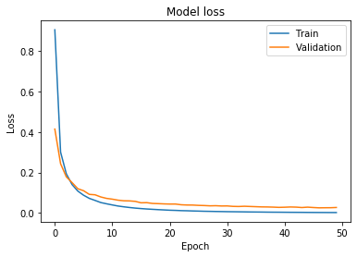 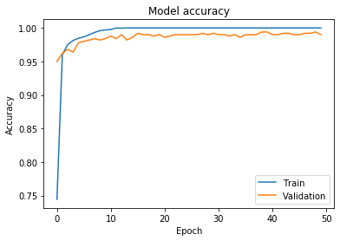

**ResNet 50_Aug3**

Train: 100, Val: 99.4, Test: 99.2

|  |  |  |  |  |  |  |  |  |  |
| --- | --- | --- | --- | --- | --- | --- | --- | --- | --- |
| 50 | 0 | 0 | 0 | 0 | 0 | 0 | 0 | 0 | 0 |
| 0 | 50 | 0 | 0 | 0 | 0 | 0 | 0 | 0 | 0 |
| 0 | 0 | 50 | 0 | 0 | 0 | 0 | 0 | 0 | 0 |
| 0 | 0 | 0 | 50 | 0 | 0 | 0 | 0 | 0 | 0 |
| 0 | 0 | 0 | 0 | 50 | 0 | 0 | 0 | 0 | 0 |
| 0 | 0 | 0 | 0 | 0 | 50 | 0 | 0 | 0 | 0 |
| 0 | 0 | 1 | 0 | 0 | 0 | 49 | 0 | 0 | 0 |
| 0 | 0 | 0 | 0 | 0 | 0 | 0 | 48 | 1 | 1 |
| 0 | 0 | 0 | 0 | 0 | 0 | 0 | 1 | 49 | 0 |
| 0 | 0 | 0 | 0 | 0 | 0 | 0 | 0 | 0 | 50 |

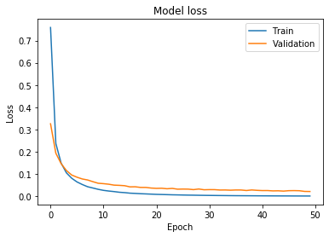 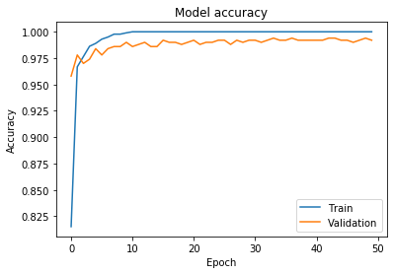

**ResNet 50_Aug4**

Train: 100, Val: 99.4, Test: 99.2

|  |  |  |  |  |  |  |  |  |  |
| --- | --- | --- | --- | --- | --- | --- | --- | --- | --- |
| 50 | 0 | 0 | 0 | 0 | 0 | 0 | 0 | 0 | 0 |
| 0 | 50 | 0 | 0 | 0 | 0 | 0 | 0 | 0 | 0 |
| 0 | 0 | 50 | 0 | 0 | 0 | 0 | 0 | 0 | 0 |
| 0 | 0 | 0 | 50 | 0 | 0 | 0 | 0 | 0 | 0 |
| 0 | 0 | 0 | 0 | 50 | 0 | 0 | 0 | 0 | 0 |
| 0 | 0 | 0 | 0 | 0 | 50 | 0 | 0 | 0 | 0 |
| 0 | 0 | 1 | 0 | 0 | 0 | 49 | 0 | 0 | 0 |
| 0 | 0 | 0 | 0 | 0 | 0 | 0 | 48 | 1 | 1 |
| 0 | 0 | 0 | 0 | 0 | 0 | 0 | 1 | 49 | 0 |
| 0 | 0 | 0 | 0 | 0 | 0 | 0 | 0 | 0 | 50 |

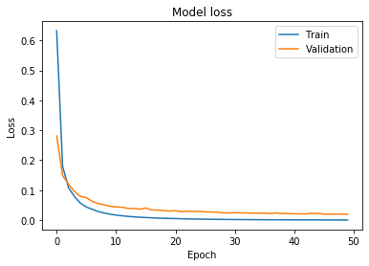 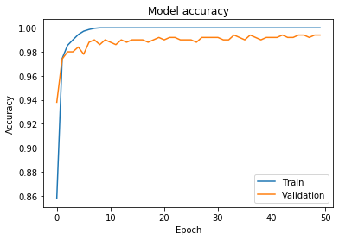

**ResNet 50_Aug5**

Train: 100, Val: 99.4, Test: 99

|  |  |  |  |  |  |  |  |  |  |
| --- | --- | --- | --- | --- | --- | --- | --- | --- | --- |
| 50 | 0 | 0 | 0 | 0 | 0 | 0 | 0 | 0 | 0 |
| 0 | 50 | 0 | 0 | 0 | 0 | 0 | 0 | 0 | 0 |
| 0 | 0 | 50 | 0 | 0 | 0 | 0 | 0 | 0 | 0 |
| 0 | 0 | 0 | 50 | 0 | 0 | 0 | 0 | 0 | 0 |
| 0 | 0 | 0 | 0 | 50 | 0 | 0 | 0 | 0 | 0 |
| 0 | 0 | 0 | 0 | 0 | 50 | 0 | 0 | 0 | 0 |
| 0 | 0 | 1 | 0 | 0 | 0 | 49 | 0 | 0 | 0 |
| 0 | 0 | 0 | 0 | 0 | 0 | 0 | 47 | 1 | 2 |
| 0 | 0 | 0 | 0 | 0 | 0 | 0 | 1 | 49 | 0 |
| 0 | 0 | 0 | 0 | 0 | 0 | 0 | 0 | 0 | 50 |

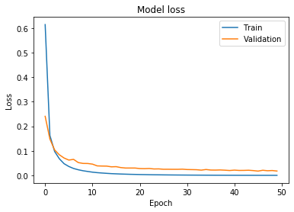 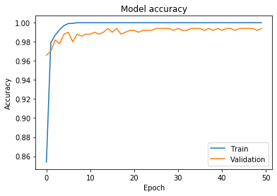

**ResNet 50_GAN1**

Train: 100, Val: 99.2, Test: 98

|  |  |  |  |  |  |  |  |  |  |
| --- | --- | --- | --- | --- | --- | --- | --- | --- | --- |
| 50 | 0 | 0 | 0 | 0 | 0 | 0 | 0 | 0 | 0 |
| 0 | 50 | 0 | 0 | 0 | 0 | 0 | 0 | 0 | 0 |
| 0 | 0 | 50 | 0 | 0 | 0 | 0 | 0 | 0 | 0 |
| 0 | 0 | 0 | 50 | 0 | 0 | 0 | 0 | 0 | 0 |
| 0 | 0 | 0 | 0 | 50 | 0 | 0 | 0 | 0 | 0 |
| 0 | 0 | 0 | 0 | 0 | 50 | 0 | 0 | 0 | 0 |
| 0 | 0 | 2 | 0 | 0 | 0 | 48 | 0 | 0 | 0 |
| 0 | 0 | 0 | 0 | 0 | 0 | 0 | 48 | 0 | 2 |
| 0 | 0 | 0 | 1 | 0 | 0 | 0 | 2 | 47 | 0 |
| 0 | 0 | 0 | 0 | 0 | 0 | 0 | 2 | 1 | 47 |

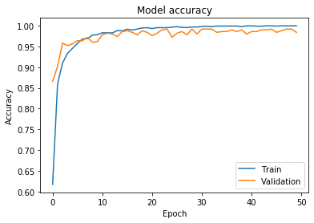 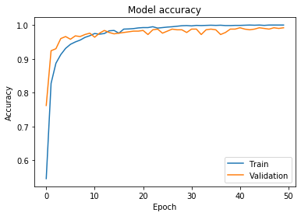

**ResNet 50_GAN2**

Train: 99.97, Val: 99.2, Test: 97.8

|  |  |  |  |  |  |  |  |  |  |
| --- | --- | --- | --- | --- | --- | --- | --- | --- | --- |
| 50 | 0 | 0 | 0 | 0 | 0 | 0 | 0 | 0 | 0 |
| 0 | 50 | 0 | 0 | 0 | 0 | 0 | 0 | 0 | 0 |
| 0 | 0 | 50 | 0 | 0 | 0 | 0 | 0 | 0 | 0 |
| 0 | 0 | 0 | 50 | 0 | 0 | 0 | 0 | 0 | 0 |
| 0 | 0 | 0 | 0 | 50 | 0 | 0 | 0 | 0 | 0 |
| 0 | 0 | 0 | 0 | 0 | 50 | 0 | 0 | 0 | 0 |
| 0 | 0 | 2 | 0 | 0 | 0 | 48 | 0 | 0 | 0 |
| 0 | 0 | 0 | 0 | 0 | 0 | 0 | 47 | 1 | 2 |
| 0 | 0 | 0 | 1 | 0 | 0 | 0 | 2 | 47 | 0 |
| 0 | 0 | 0 | 0 | 0 | 0 | 0 | 2 | 1 | 47 |

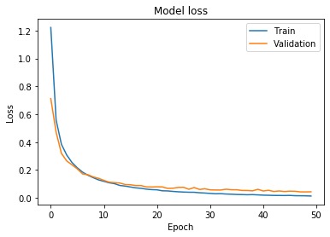 

**ResNet 50_GAN3**

Train: 99.80, Val: 98.80, Test: 98

|  |  |  |  |  |  |  |  |  |  |
| --- | --- | --- | --- | --- | --- | --- | --- | --- | --- |
| 50 | 0 | 0 | 0 | 0 | 0 | 0 | 0 | 0 | 0 |
| 0 | 50 | 0 | 0 | 0 | 0 | 0 | 0 | 0 | 0 |
| 0 | 0 | 50 | 0 | 0 | 0 | 0 | 0 | 0 | 0 |
| 0 | 0 | 0 | 50 | 0 | 0 | 0 | 0 | 0 | 0 |
| 0 | 0 | 0 | 0 | 50 | 0 | 0 | 0 | 0 | 0 |
| 0 | 0 | 0 | 0 | 0 | 50 | 0 | 0 | 0 | 0 |
| 0 | 0 | 2 | 0 | 0 | 0 | 48 | 0 | 0 | 0 |
| 0 | 0 | 0 | 0 | 0 | 0 | 0 | 48 | 0 | 2 |
| 0 | 0 | 0 | 1 | 0 | 1 | 0 | 2 | 46 | 0 |
| 0 | 0 | 0 | 0 | 0 | 0 | 0 | 2 | 0 | 48 |

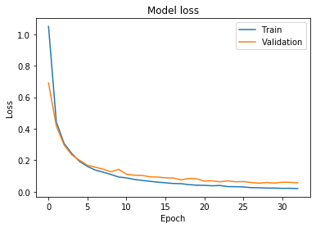 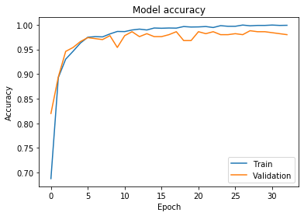

**ResNet 50_GAN4**

Train: 99.96, Val: 98.60, Test: 97.8

|  |  |  |  |  |  |  |  |  |  |
| --- | --- | --- | --- | --- | --- | --- | --- | --- | --- |
| 50 | 0 | 0 | 0 | 0 | 0 | 0 | 0 | 0 | 0 |
| 0 | 50 | 0 | 0 | 0 | 0 | 0 | 0 | 0 | 0 |
| 0 | 0 | 50 | 0 | 0 | 0 | 0 | 0 | 0 | 0 |
| 0 | 0 | 0 | 50 | 0 | 0 | 0 | 0 | 0 | 0 |
| 0 | 0 | 0 | 0 | 50 | 0 | 0 | 0 | 0 | 0 |
| 0 | 0 | 0 | 0 | 0 | 50 | 0 | 0 | 0 | 0 |
| 0 | 0 | 2 | 0 | 0 | 0 | 48 | 0 | 0 | 0 |
| 0 | 0 | 0 | 0 | 0 | 0 | 0 | 48 | 0 | 2 |
| 0 | 0 | 0 | 1 | 0 | 1 | 0 | 3 | 45 | 0 |
| 0 | 0 | 0 | 0 | 0 | 0 | 0 | 2 | 0 | 48 |

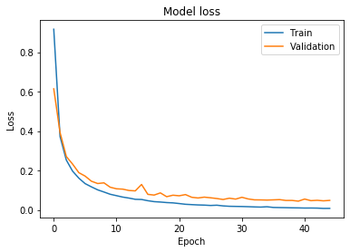 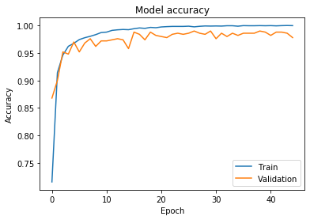

**ResNet 50_GAN4**

Train: 99.92, Val: 98.80, Test: 98.2

|  |  |  |  |  |  |  |  |  |  |
| --- | --- | --- | --- | --- | --- | --- | --- | --- | --- |
| 50 | 0 | 0 | 0 | 0 | 0 | 0 | 0 | 0 | 0 |
| 0 | 50 | 0 | 0 | 0 | 0 | 0 | 0 | 0 | 0 |
| 0 | 0 | 50 | 0 | 0 | 0 | 0 | 0 | 0 | 0 |
| 0 | 0 | 0 | 50 | 0 | 0 | 0 | 0 | 0 | 0 |
| 0 | 0 | 0 | 0 | 50 | 0 | 0 | 0 | 0 | 0 |
| 0 | 0 | 0 | 0 | 0 | 50 | 0 | 0 | 0 | 0 |
| 0 | 0 | 2 | 0 | 0 | 0 | 48 | 0 | 0 | 0 |
| 0 | 0 | 0 | 0 | 0 | 0 | 0 | 48 | 0 | 2 |
| 0 | 0 | 0 | 1 | 0 | 0 | 0 | 2 | 47 | 0 |
| 0 | 0 | 0 | 0 | 0 | 0 | 0 | 2 | 0 | 48 |

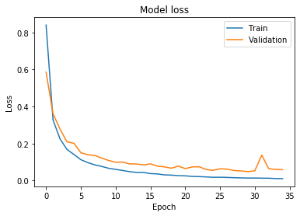 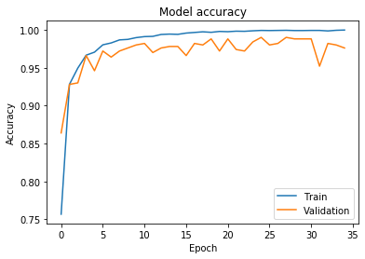

**ImageDataGen**

**inception_v3_horizontal_flip**

Train: 100, Val: 97.80, Test: 96.20

 

|  |  |  |  |  |  |  |  |  |  |
| --- | --- | --- | --- | --- | --- | --- | --- | --- | --- |
| 50 | 0 | 0 | 0 | 0 | 0 | 0 | 0 | 0 | 0 |
| 0 | 50 | 0 | 0 | 0 | 0 | 0 | 0 | 0 | 0 |
| 0 | 0 | 49 | 0 | 0 | 0 | 0 | 0 | 1 | 0 |
| 0 | 0 | 0 | 50 | 0 | 0 | 0 | 0 | 0 | 0 |
| 0 | 0 | 0 | 0 | 50 | 0 | 0 | 0 | 0 | 0 |
| 0 | 0 | 1 | 0 | 0 | 47 | 0 | 2 | 0 | 0 |
| 0 | 0 | 1 | 0 | 0 | 0 | 49 | 0 | 0 | 0 |
| 0 | 0 | 0 | 0 | 0 | 0 | 0 | 45 | 2 | 3 |
| 0 | 0 | 0 | 0 | 0 | 0 | 0 | 1 | 47 | 2 |
| 0 | 0 | 0 | 0 | 0 | 3 | 0 | 3 | 0 | 44 |

**inception_v3_vertical_flip**

Train: 100, Val: 97.20, Test: 95.6

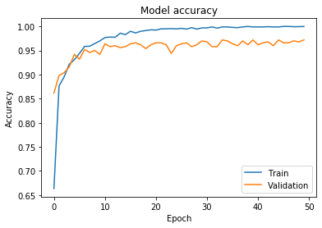 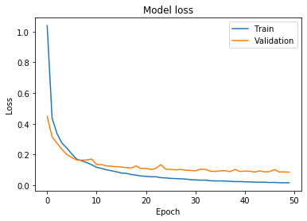

|  |  |  |  |  |  |  |  |  |  |
| --- | --- | --- | --- | --- | --- | --- | --- | --- | --- |
| 50 | 0 | 0 | 0 | 0 | 0 | 0 | 0 | 0 | 0 |
| 0 | 50 | 0 | 0 | 0 | 0 | 0 | 0 | 0 | 0 |
| 0 | 0 | 48 | 0 | 0 | 0 | 0 | 0 | 2 | 0 |
| 0 | 0 | 0 | 50 | 0 | 0 | 0 | 0 | 0 | 0 |
| 0 | 0 | 0 | 0 | 50 | 0 | 0 | 0 | 0 | 0 |
| 0 | 0 | 0 | 0 | 0 | 47 | 0 | 2 | 0 | 1 |
| 0 | 0 | 0 | 0 | 0 | 0 | 50 | 0 | 0 | 0 |
| 0 | 0 | 0 | 0 | 0 | 0 | 0 | 42 | 1 | 7 |
| 0 | 0 | 0 | 1 | 0 | 1 | 1 | 1 | 45 | 1 |
| 0 | 0 | 0 | 0 | 0 | 1 | 0 | 2 | 1 | 46 |

**inception_v3_** **width_shift**

Train: 100, Val: 97.40, Test: 96.2

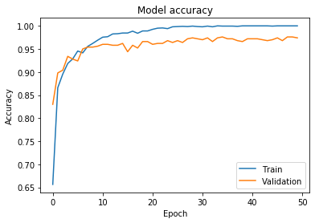 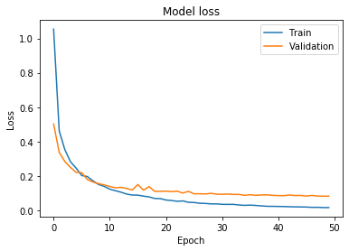

|  |  |  |  |  |  |  |  |  |  |
| --- | --- | --- | --- | --- | --- | --- | --- | --- | --- |
| 50 | 0 | 0 | 0 | 0 | 0 | 0 | 0 | 0 | 0 |
| 0 | 50 | 0 | 0 | 0 | 0 | 0 | 0 | 0 | 0 |
| 0 | 0 | 49 | 0 | 0 | 0 | 0 | 0 | 1 | 0 |
| 0 | 0 | 0 | 50 | 0 | 0 | 0 | 0 | 0 | 0 |
| 0 | 0 | 0 | 0 | 50 | 0 | 0 | 0 | 0 | 0 |
| 0 | 0 | 1 | 0 | 0 | 48 | 0 | 1 | 0 | 0 |
| 0 | 0 | 0 | 0 | 0 | 0 | 50 | 0 | 0 | 0 |
| 0 | 0 | 0 | 0 | 0 | 0 | 0 | 46 | 2 | 2 |
| 0 | 0 | 0 | 1 | 0 | 0 | 0 | 4 | 44 | 1 |
| 0 | 0 | 0 | 0 | 0 | 2 | 0 | 4 | 0 | 44 |